TITLE II

FOOD

Paragraph I

General Provisions
ARTICLE 95.- For the purposes of applying the provisions of these regulations, the responsibility for the activities of production, importation, packaging, and marketing of foods will individually or jointly correspond, as determined by the competent Health Service, to the producer, importer, packer, distributor, seller, or holder of the product.
ARTICLE 96.- The manufacture, possession, distribution, sale, or transfer of processed or packaged foods in the country where, although intended for export, come from establishments which have not been authorized by the competent health authority, is prohibited.
ARTICLE 97.- Export foods that do not meet the standards set out in this regulation will bear the key "Z" printed prominently and indelibly on their containers. These foods can not be marketed in the country.
ARTICLE 98.- An altered food refers to one that, due to natural causes of physical, chemical, or biological nature, or causes resulting from technological treatments, alone or combined, has suffered a change or deterioration in its organoleptic characteristics, in composition, and/or its nutritional value.

ARTICLE 99.- Adulterated food refers to one that has, due to human intervention, suffered changes that alter its characteristics or qualities, without being expressly stated on the label, such as:
- partial or complete removal of any component of the original product;
- the partial or total replacement of any component of the original product by other inert or foreign items, including the addition of water or other filler material;
- the mixing, coloring, spraying, or covering in such a way as to hide their inferiority or decrease its purity.
ARTICLE 100.- Counterfeit food is one which:
- is designated, labeled, or sold with a name or qualifier not corresponding to its origin, identity, or nutritional or stimulative value, and
- whose packaging, sign, or advertisement contains any design or ambiguous statement, false or misleading with respect to the ingredients in the food.
ARTICLE 101.- Contaminated food refers to one that contains:
- microorganisms, viruses and/or parasites, foreign or deleterious substances of mineral, organic or biological, radioactive, and/or toxic substances in quantities greater than those permitted by regulations, or presumed to be harmful to health;
- any dirt, debris, excrement;
- additives not authorized by the regulations in force or in amounts exceeding those permitted.
ARTICLE 102.- It is prohibited to manufacture, import, possess, distribute, sell, or transfer to any title, for any purposes, altered, contaminated, adulterated, or counterfeit food.
ARTICLE 103.- No transfer of title shall be made on any food, raw materials from customs lags, from transport companies or fire rescues, catastrophes, and disasters without the approval of the health authority.
ARTICLE 104.- The interested party or the auctioneer in charge of the auction, if applicable, must request at least twenty days prior to the title transfer an inspection visit to check the health status of the products, accompanied for such purposes by their inventory.
ARTICLE 105.- Foods that pose a risk to health must be confiscated by the health authority, and may be retained in the custody of its owner or holder with prohibition on their transfer, use, sale, or distribution of any type. To this end, food establishments must define a sufficient and adequate physical space for storing food products unfit for human consumption, products that must have a clear, unambiguous, and indelible mark, for example, a red X or other similar sign in terms of prohibition.
These products may be intended for non-food industrial use or animal feed, provided that the denaturation is authorized by the competent health authority and, in case this is not possible, or is not of interest to its owner, must be destroyed, an action which will also be authorized, including final disposal in a suitable premises.
The health authorization for denaturation must be expressly granted prior to payment of the appropriate fee, the cost of operation being responsibility of the person concerned, or its owner or holder, as applicable.

Paragraph II

Labeling and Advertising
ARTICLE 106.- For the purposes of these regulations the terms below have the following meaning:
- Food Substitute: Food intended to resemble a common food, due to its texture, aroma, taste, or smell, and is used as a complete or partial substitute of the food it resembles;
- Dried Foods: Refers to dehydrated fruits, vegetables, or legumes, even when taking oral pharmaceutical forms;
- Addition: Addition of one or more nutrients or dietary factors, for example, dietary fiber to a food for nutritional purposes, in a concentration of less than 10% of the Daily Reference Values (DRV), per average serving size for a particular nutrient;
- New Food, Ingredient, and Material: Those foods, food ingredients, and material obtained through physical-chemical synthesis processes or by processes that occur in nature that are not typical of molecules or compounds typical of human consumption;
- Supplementation: Is the addition of nutrients to the food, in order to produce a characteristic healthy nutritional or physiological effect;
- Complementation: Adding nutrients to a food lacking or containing them in minimum amounts for the purpose of producing a nutritional effect; complementation comprises the concepts of addition, enrichment or fortification, as well as supplementation, according to the percentage of the added nutrient, based on the Recommended Daily Allowance and per average serving size.
- Nutrient Declaration: Standardized statement or listing of the nutrient content of a food;
- Nutritional Claim: Any representation which states, suggests or implies that a food has particular nutritional properties, especially but not only in terms of energy value, protein, fat, and carbohydrates available, but also by the content of vitamins, minerals and other factors food, such as dietary fiber and cholesterol;
- Health Claim: Any representation which states, suggests, or implies that a relationship exists between a food, nutrient, or other substance contained in a food and a health-related condition;
- Descriptor: The term or word that defines or describes a certain characteristic that is attributed to a food;
- Dietary Factor: Nutrient substances and non-nutrient substances that play a role in our body, such as cholesterol, dietary fiber and other;
- Enrichment or fortification: The addition of one or more nutrients or dietary fiber to a food, in a concentration of 10% or more of the Daily Reference Values (DRV) per average serving size for a particular nutrient;
- container: any vessel containing food, covering it fully or partially.
- Biotechnological event: Association or combination of genes from different species resulting from genetic engineering, different or in a different order with respect to what occurs spontaneously in nature;
- Date or period of minimum duration: The expiration date or period of the period which the manufacturer guarantees that the product, stored under certain storage conditions, if any, maintains all significant qualities attributed to it, tacitly or explicitly, without this meaning that the product cannot be marketed beyond this date or period. The use of date or period of minimum duration is optional;
This date or period of minimum duration may be given as a recommendation, and the expression "best before" or equivalent may be used;
- Date of preparation: The date on which the food becomes the product as described on the package;
- Date of packaging: The date on which the food is placed in the container in which it will eventually be sold;
- Expiration date or duration period: The date or period in which the manufacturer states that, under certain storage conditions, the period during which the product maintains the expected quality attributes ends. After that date or when that period has passed, the product cannot be marketed.
For the purposes of using the duration period, it is understood that it starts to take effect from the date of manufacture.
The expiration date or the duration period must be clearly defined. In these cases, expressions such as "best before", or other equivalents, that subtract accuracy or reduce the importance of the due date or the duration period shall not be accepted;
- Ingredient: Any substance, including additives, that are used in the manufacture or preparation of a food and is present in the final product, albeit in a modified form;
- Characterizing ingredient: An ingredient that gives the food peculiar attributes that distinguish it clearly from other foods of the same type;
- Batch: Certain quantity of a food produced in essentially the same conditions;
- Normalization or standardization: The addition or removal of nutrients to a food in order to compensate for natural variations in the content of nutrients;
- Nutrient: Any substance normally consumed as a constituent of a food and that is necessary for growth, development, and normal body maintenance or whose deficiency causes characteristic biochemical or physiological changes;
- Essential nutrient: Any substance consumed as a constituent of food necessary for growth, development, and maintenance of vital functions and cannot be synthesized in sufficient quantities by the human body;
- average serving size: amount of food generally consumed by a person in one sitting, defined in terms of the edible part of the product and referred to the product as it is marketed.
For dehydrated food products that are consumed once reconstituted, the average serving size will be reported according to the reconstitution instructions.
- Restitution: Addition to a food of one or more nutrients that have been lost during the process of manufacturing, storage, and handling in such amounts that result in the recovery of such losses;
- Labeling: Set of inscriptions, legends, or illustrations contained on the label which provide information about the characteristics of a food product;
- Labeling or nutrition labeling: Any description intended to inform consumers about the nutritional properties of a food product. Includes the nutrient declaration and supplementary nutritional information;
- Label: Tag, label, brand, image, or other descriptive or graphic material that has been written, printed, stenciled, marked, embossed or engraved, or attached to the container of a food;
- Available Carbohydrates: The total of carbohydrates excluding dietary fiber
- Ready-to-eat (RTE) foods: all food intended by the producer, manufacturer, or packer for direct human consumption without the need for cooking or other processing effective in eliminating or reducing dangerous microorganisms to an acceptable level.
- Food hypersensitivity: adverse reactions to nontoxic foods. They are divided into food Allergies and non-allergic Hypersensitivity to food.
- Reference food: Similar food that serves as a standard of comparison to perform and highlight a nutritional modification, restricted to a short descriptor and its synonyms. This reference food must be present in the market and be of one's own manufacturing. Only in its absence may other foods, also present in the market, be considered for comparison.
- Advertising: Any type of promotion, communication, recommendation, publicity, information or action aimed at promoting the consumption of a given product.
- Pre-processed vegetables: fruits or vegetables, combined or not, processed for consumption in order to keep them organoleptically fresh through operations such as: removal of inedible parts, chopping, rolling, crushing, cubing, centrifugation, sanitizing and packaging, which can extend their shelf life through the reduction and control of microbiological load and packaging conditions or other technological processes.
ARTICLE 107.- All food products that are stored, transported, or dispensed packaged must bear a label or tag containing the following information:
- food name. The name must specifically indicate the true nature of the food. Notwithstanding the name, the brand may be given. In substitute products, this condition must be clearly indicated.
Next to the name or very close to it there must appear the additional words or phrases necessary to avoid errors or deceit regarding the true nature and physical condition of the food, including but not limited to the packing type or medium, the form of presentation, or the type of treatment it has undergone;
- net content expressed in units of the metric system or the international system, with the unit symbol or full word. No term with ambiguous meaning must accompany the values of net content .
In addition to the declaration of net content, for food packed in a liquid medium, the drained weight of the food must be indicated in units of the metric system or the international system;
- For domestic foods, the name or business name and address of the manufacturer, producer, processor, packer, or distributor, as applicable;
- country of origin must be clearly indicated in both domestic and imported products, in accordance with established labeling standards regarding this information, in Decree No. 297 of 1992, of the Ministry of Economy, Development, and Reconstruction, or in the legislation that replaces it;
- number and date of the resolution and the name of the Health Service authorizing the establishment that prepares or packs the product or authorizes its placement;
- date of manufacture or packaging date of the product. This must be legible, and placed in an area of the package that is easily located and must be stated in the following manner and order:
- the day, using two digits
- the month, using two digits or the first three letters of the month, and
- the year, using the last two digits.
For products whose minimum duration is less than or equal to 90 days, the year may be omitted. For products whose minimum duration is no less than three months, the day may be omitted.
The industry can identify the date of manufacture with the code corresponding to the production batch. In this case the latter's records must be available at all times to the health authority;
- expiration date or duration of the product. This information shall be placed on the packaging in a place that is easily located and with a prominent legend. The expiration date shall be indicated in the form and order set for the date of manufacture. The duration must be indicated in terms of days or months or years, as applicable, always using whole units, unless it is of "indefinite duration," in which case the information must be entered.
For products identifying the date of manufacture with the code of the production batch, the duration must be labeled in terms of the expiration date, while those expressly indicating the date of manufacture may use the expiration date or duration period.
Products with a label of "indefinite" must necessarily indicate the date of manufacture.
- ingredients, on the label must be included the list of all ingredients and additives that make up the product, with their specific names, in descending order of proportion, except for flavor and aroma enhancers, pursuant to the provisions of Article 136 of this regulation.
When the food, ingredient, or derivative is or contains any of the substances that cause hypersensitivity (food allergens), as officially recognized by resolution of the Ministry of Health, published in the Official Gazette, the allergen(s) must be indicated in the list of ingredients, in letters of a size no less than the letters of the general ingredients, or with the heading "Contains ... " or similar. If the ingredient is a derivative of any of the allergens recognized by the resolution, then both the ingredient and the allergen must be labeled, as in the following example: casein (milk) or milk casein.
If the food is at risk of contamination, from production or processing to marketing, from said allergens, then any of the following phrases must be included after the list of ingredients: "May contain ... ", "Contains small amounts of ...", "Contains traces of ... " or "Made in lines that also process ....", listing the allergen in question.
- additives, the incorporation of additives must be indicated on the label, in descending order of concentration, with their specific names, with the exceptions noted in the corresponding title. Any food additive that has been used in raw materials and other ingredients in a food, and passes to the food in sufficient quantity to perform a technological function in it, must be included in the ingredient list.
j) nutritional information pursuant to the provisions of Article 115 of this regulation;
k) storage instructions, in addition to the date of minimum duration, special conditions required for the preservation of food must be indicated on the label, if the validity of the date of minimum duration depends on its compliance. In the event that, once opened, the product requires refrigeration or another special environment, this should also be noted in the labeling;
a. instructions for use, the label must contain the necessary instructions, including reconstitution, where applicable, to ensure the correct use of the food;
m) For imported products, the name and address of the importer. The importer must maintain a record of all items admitted into the country, for a minimum period of 90 days after the expiration date or the duration of the product, as appropriate. Foods of indefinite duration must be kept on record for at least three years.
This record must provide background information to the customs agency at destination, the health history of the product, the authorization for use and consumption, the codes of the production batches or dates of manufacture, expiration date, country of origin, type of product, brand, the name of the foreign supplier and must be, at all times, available to the Health Authority.
The code of the production batch or date of manufacture shall also be stamped on the package and thus distinguish, unequivocally, different production batches or lots.
Imported foods must comply with all other applicable labeling rules on everything not specifically regulated herein. The authorization for admittance and consumption shall be done item by item, being, therefore, subject to all the controls that the Health Authority needs to perform, as provided herein.
n) the food and/or raw material for human consumption, modified through biotechnology events that present different nutritional characteristics to those of the food and/or conventional feedstock, must list them on the label, pursuant to the provisions of Articles 113 and 115 to 120 of this regulation.
ARTICLE 108.- Further, imported products must comply with all labeling provisions set forth herein. On any information specified in this regulation and that has not been included in the original labeling, and that is not in Spanish or is not indicated in accordance with the provisions of this regulation, must be placed on a label permanently affixed to the container, with an appropriate size and location.
ARTICLE 109.- Article 109: The information on the label shall be in Spanish, and may be circumstantially repeated in another language. Data shall be showed with visible, indelible characters, and [shall be] easy to read under normal purchase and use circumstances. Neither overprints nor modifications of the information contained in the original label will be allowed, unless written authorization from the health authority is obtained, with the following exceptions:

1) Imported products that are labeled in another language or do not comply with the requirements of the present rules regarding labeling;
2) Products using overprint or modification of the information on the label as provided herein by Article 120 bis, including the nutritional information adjustment that must be declared or eliminating information incompatible with such descriptor, if applicable."

ARTICLE 110.- The labeling and advertising of any type must not contain words, pictures and/or other graphic representations that can lead to misunderstandings, deceit, or falsehood, or that in some way are likely to create an erroneous impression regarding the nature, composition, or quality of the product. Likewise, therapeutic effects, curative effects, or dosages must not be suggested or indicated.
In foods or food products containing flavor and aroma enhancers (natural flavor and aroma enhancers, flavor and aroma enhancers identical to natural, and/or artificial flavor and aroma enhancers), graphical representation of the food or substance whose flavor characterizes the product is allowed, even though the food does not contain it, while the name of the food must be accompanied by the expressions: "Flavor of ..." or "Flavor ..." filling the blank with the name of the characterizing flavor or flavors, with identical letters in color, sharpness, and visibility.
To highlight the lack of nutrients, dietary factors or ingredients, naturally or usually absent in food, this must be done in general terms and not as an exclusive feature of the food making the statement.
Article 110 bis: No advertising may be targeted towards those under the age of 14, whatever the place where this is performed when it comes to any food product or foodstuff which, in its nutritional composition contains energy, sodium, sugar or saturated fat in amounts over those detailed herein under Table N°1 of Article 120 bis,

For these purposes, advertising shall be construed as targeted towards this age group if it uses, among other elements, childish characters and figures, animations, cartoons, toys, children's music, where people or animals appear attracting the interest of those under the age of 14, or if it contains fantasy-based statements or reasons regarding the product or its effects, childish voices, language or expressions typical of youngsters, or situations that represent their daily life, such as school, breaks or children's games. This qualification shall be justified.

Likewise, no interactive applications, games, competitions or other similar elements may be used for advertising these foods targeted towards those under the age of 14.

Moreover, advertising of such food products or foodstuffs shall further be construed as targeted towards those under the age of 14 when it is effected by means of programs or web sites targeted towards said audience; or when these programs or websites capture the attention of an audience under the age of 14, of over 20%. Nor may such food products or foodstuffs be publicized in advertising spaces during, between or immediately before or after media campaigns regarding such programs or websites.

Food products or foodstuffs containing energy, sodium, sugar or saturated fat in amounts over those detailed herein under Table N° 1 of Article 120 bis, may not be offered or delivered for free to those under the age of 14, nor use cross-promotions targeted towards them, which bear no relation to the product's actual publicity, such as toys, accessories, stickers, incentives or others of a similar nature.

These food products or foodstuffs may not be retailed, marketed, advertised or publicized in preschool, primary or high school institutions.

Advertising of these foods performed through mass media shall contain a message promoting healthy lifestyles whose characteristics shall be determined by a Ministry of Health's Supreme Decree "issued by order of the President of the Republic."

Foods or mixes of them, which have no added sugar, honey, syrup, sodium or saturated fat will be excluded from the provisions of this Article.

ARTICLE 111.- The information must be placed in the container so as not to be separated from it. Where the container is covered by a non-transparent wrapper, all the required information must appear on it.
ARTICLE 112.- Where, in the labeling of a food, the presence or content of one or more characterizing ingredients stand out, or when the same effect is produced in the description of the food, the percentage of the mass/mass ingredient(s) in the final product must be reported. Ingredients subject to specific conditions or criteria for labeling in other Articles herein or its complementary resolutions are excluded from the application of this article.
ARTICLE 113.- In nutritional labeling, supplementary nutrition information may optionally be included and, when included, it must write out, beside the main name of the food or part thereof or together with the nutritional information, in visible characters, the corresponding nutritional descriptor pursuant to the provisions of Article 120 herein.
Article 114.- All foods that make health claims in their labeling or advertising, or when the description has the same effect, will be required to comply with the declaration of nutrients as required by this regulation. The health claims must be scientifically recognized or internationally agreed upon and framed within the technical standards on nutritional guidelines approved by resolution of the Ministry of Health, to be published in the Official Gazette.
Both the claim to health properties and the claim to nutritional properties for a food, or when its description produces the same effect in its labeling and/or advertising, may not make false associations, induce unnecessary consumption of a food or grant a feeling of protection in relation to a disease or condition of health deterioration.
It is the responsibility of the manufacturer, importer, and/or final packer, that all information on the label be accurate and fulfill the provisions of this regulation.
Article 115.- All packaged foods ready for delivery to the end consumer shall mandatorily include in their labeling the following nutritional information:
- Energy value expressed in calories (in kcal), the amounts of protein, total fat, available carbohydrates and total sugars, in grams (in g) and sodium in milligrams (in mg).
In those products whose total fat content is no less than 3 grams per average serving size, in addition to total fat, the amounts of saturated fatty acids, monounsaturated, polyunsaturated and trans fatty acids must be declared in grams and cholesterol in milligrams.
For foods that contain an amount equal to or less than 0.5 grams of trans fat acids per average serving size, the statement indicating that the food contains at most 0.5 grams of trans fatty acids per serving may be accepted as an alternative.
For foods that contain an amount equal to or less than 35 milligrams of sodium per average serving size, the statement indicating that the food contains at most 35 milligrams of sodium per serving may be accepted as an alternative.
For foods that contain an amount equal to or less than 0.5 grams of sugar per average serving size, the statement indicating that the food contains at most 0.5 grams of sugar per serving may be accepted as an alternative.
- The amount of any other nutrient or dietary factor, such as dietary fiber and cholesterol, about which a nutrition and/or health claim is made.
All these values must be expressed per 100 g or 100 ml per average serving size of the food. Details should include the number of servings in the package and the serving size in grams or milliliters and home measures.
The values used in the nutrient declaration must be weighted average values derived from data specifically obtained through food analysis performed in laboratories or food composition tables that are duly recognized by national or international bodies, and which are representative of the food in the declaration.
The tolerance limits for nutrient values declared on the label shall be as follows:
For foods declaring nutritional or healthy messages on their labeling and foods using nutritional descriptors, except those labeling the descriptor of Article 120 bis herein, the tolerance limits for the declared value of the nutrient in reference, shall be the following:
- when nutrients and dietary factors are expressed as proteins, vitamins, minerals, dietary fiber, and/or monounsaturated and polyunsaturated fats, they must be present in an amount greater than or equal to the value declared on the label;
- when nutrients and dietary factors are expressed as energy, carbohydrates, sugars, total fat, cholesterol, saturated fat, trans fat and/or sodium, they must be present in an amount less than or equal to the value declared on the label.
For food that in its labeling does not highlight nutritional or healthy messages or use nutritional descriptors, the tolerance limits for the nutritional labeling shall be as follows:
- when nutrients and dietary factors are expressed as proteins, vitamins, minerals, dietary fiber and/or monounsaturated and polyunsaturated fats, they must be present in an amount greater than or equal to 80% of the value declared on the label;
- when nutrients and dietary factors are expressed, such as energy, carbohydrates, sugars, total fat, cholesterol, saturated fat, trans fat and/or sodium, they may only exceed 20% of the value declared on the label.
The previously described tolerance will also be applicable to the nutritional descriptors referred to in Article 120 bis herein
In any case, the limits of vitamins, minerals, and dietary fiber must not exceed the values set forth in Resolution No. 393/02, as amended, which sets forth Nutritional Guidelines on the Use of Vitamins, Minerals and Dietary Fiber in Food, and Resolution No. 394/02, as amended, which sets forth the Nutritional Guidelines on Dietary Supplements and their contents in Vitamins and Minerals, all from the Ministry of Health.
For those nutrients whose percentage of variability, depending on the kind and type of handling, exceeds the permitted tolerance, the company must make available to the health authority the technical background to justify it.
The following shall be exempt from compliance with the above provisions of this Article:
- Predefined foods, sliced, and packaged prior to time of sale at the place of sale, including ready-to-eat meals, which must comply with the provisions of Article 468 herein;
- Stimulants without the addition of other ingredients, additives, processing coadyuvants, spices alone or in mixtures without other ingredients, and fruits and vegetables in their natural state;
- Foods that are marketed in bulk, portioned, or divided, and those prepared at the request of the public, although they are packaged at the time of sale.
Optionally, the nutrient declaration can be made on the label of foods that have no obligation to do so, which, in any case, shall be in accordance with the provisions of these regulations.
The numerical expression of the nutrients and dietary factors, the approximation in order to express the values of nutrients and dietary factors, and the expression of values of normal serving sizes and household measures, shall be performed according to the following criteria:
Numeric expression of nutrients and dietary factors:
Values equal to or greater than 100 | Shall be declared as whole numbers
Values less than 100 and greater than or equal to 10 | Shall be declared as whole numbers or with a decimal
Values less than 10 and greater than or equal to 1 | Shall be declared as whole numbers or with up to two decimal places
Values less than 1 | Shall be declared with up to two decimal places
Approximation criteria for values of nutrients and dietary factors reported in numbers with decimals.
- If the digit to be dropped is equal to or greater than 5, the previous digit is increased by one unit.
- If the digit to be dropped is less than 5, the previous digit remains unchanged.
The numerical expression of the number of normal servings must be in whole numbers and the expression of the serving size in household measures may be in units, slices, pieces, cups, tablespoons or similar, or their parts, such as half a tablespoon or 1/4 cup. When the result of dividing the contents of the package by the defined serving size is not a whole number, or when it is not easily definable, the servings will be approximated with the criteria of mathematical approximation of the values of nutrients and dietary factor values, as described above. When mathematical approximation leads to the higher integer, this will require the use of the term "about" or the expression "approx. ", accompanying the whole number obtained. When mathematical approximation leads to the lower integer, the use of the term "about" or the expression "approx.", accompanying the whole number obtained, will be optional.
- The nutrient declaration must comply with the following characteristics:
- The font family to be used will be Arial, Dax, Futura, Helvetica, Myriad, Swiss, and Univers, or other equivalent families that have equal weight and visual consistency, straight cuts and profiles, without serifs, and include bold and standardized condensed versions.
- The minimum height of the letters and numbers shall be 1.2 mm measured in the height of a capital letter H in the font families defined above or their equivalent, which is roughly equivalent to 5 typographical points defined in the graphical design software programs.
- The colors used in the combination of the background with the letters and numbers used to communicate the nutritional information, should use the maximum possible contrast, using for this purpose spot or vivid colors, without color gradations or patterns.
- The information should preferably be arranged vertically, using two columns, one for the information per 100 g or 100 ml (as applicable) and the other for the information per average serving size. Horizontally tiered information or division of the information into two bodies or on the next line will be accepted.
ARTICLE 116.- Where a claim of nutritional or health properties with respect to the amount or type of carbohydrates available, in addition to the requirements of Article 115, the total amount of any available carbohydrates involved in the statement or message must be included.
When making a statement of nutritional or health properties regarding dietary fiber, in addition to the provisions of Article 115, the amount of total dietary fiber, soluble fiber, insoluble fiber and dietary fiber(s) involved in the statement or message must be included.
Likewise, when nutritional or health properties are declared regarding the amount or type of fatty acids, the amounts of saturated fatty acids, monounsaturated fatty acids, polyunsaturated, trans fatty acids and cholesterol must be provided immediately following the declaration of the total fat content. Although they make a statement of properties, use a nutritional descriptor or healthy message, foods that comply with the parameters set forth in Article 120 for the nutritional descriptor "Totally fat free," are excepted from this requirement.
ARTICLE 117.- The statement of nutritional properties, statement of health properties, statement of nutrients, and supplementary nutritional information, must adhere to the technical standards given in this regard by the Ministry of Health by resolution published in the Official Gazette.
ARTICLE 118.- When a nutrient statement is made, the vitamins and minerals that are present in significant quantities, 5% or more of the recommended intake for the population concerned, may be listed as well. The population over four years of age will use the Daily Reference Values (DRV), in energy, proteins, vitamins, and minerals proposed by the Codex Alimentarius, for vitamin E, biotin, pantothenic acid, copper and selenium, which are not specified in the Codex Alimentarius, the values proposed by the Food and Drug Administration (FDA), References Daily Intakes (RDI) shall be used.
For infants and children under four years of age, pregnant and lactating women, the respective RDIs shall be used as Daily Reference Values. For iron and vitamin A, the value of 30 mg/day for iron and 800 mcg/day for vitamin A shall be used as the Daily Reference Values during pregnancy, as set forth in the Nutritional Guidelines of the Ministry of Health.
The numerical information on vitamins and minerals shall be expressed in metric units, international system for 100 g or 100 ml, for a normal serving as a percentage of the reference Recommended Daily Intake and by package if the package contains only one serving. In addition, this information shall be specified per average serving size on the label if the number of servings contained in the package is indicated.
ARTICLE 119.- Supplementary nutrition information, which may optionally be added to the nutrient statement, will aim to facilitate consumer understanding of the nutritional value of the food and help them to interpret the statement about the nutrient(s).
ARTICLE 120.- To enhance the qualities of any food or food product in terms of energy content (energy or calories), total fat, saturated fat, trans fat, cholesterol, sugar, sugars, sodium, vitamins, minerals, proteins, docosahexaenoic acid (DHA), eicosapentaenoic acid (EPA), other nutrients and dietary fiber, only the use of the descriptors listed herein will be allowed.
The use of a descriptor must be followed by the name of the respective nutrient or dietary factor, or the word calories or energy, as appropriate.
The use of words in another language or made-up words that are unequivocally associated with nutritional characteristics, such as light, diet, high, lite, low, skinny, lean, and soft, among others, is allowed, provided they comply with the parameters of any of the descriptors permitted hereunder.
When words in another language or made-up words associated with some nutritional characteristics are used, the area occupied by the descriptor on the label must correspond to at least 33% of the area occupied by the largest word in another language or made-up word, and must be located at least once on the front of the packaging, next to the word in another language or made-up word. If the area ratio is greater than or equal to 50%, then the descriptor may be located on any side.
For the purposes of this article, for the calculation of the respective percentages, the largest word in another language and/or made-up word must be taken as reference area, and all descriptors present in product labeling must always be maintained in legible condition.
The short descriptor and its synonyms may not be used if the food meets the requirement to be described as low contribution. The low contribution descriptor may not be used to highlight a food’s sugar or sugars content.
In the statement of a food's nutritional properties, two descriptors cannot be used simultaneously to describe the same property.
Descriptors: free, low contribution, low and light in cholesterol may only be applied to foods that are free of trans fat (maximum 0.2 g of trans fat per normal serving) and contain a maximum 2 g of saturated fat per average serving size.
Foods that use the descriptors listed below must adhere to the provisions in Article 113 herein:

 | DESCRIPTOR | REQUIRED CONDITION
ENERGY CONTENT / ENERGY / CALORIES | "FREE"  "DOES NOT CONTAIN"  "FREE OF"  "WITHOUT"  "ZERO"  "0"  "0%"  "DOES NOT CONTAIN" | The average serving size contains less than 5 kcal.
ENERGY CONTENT / ENERGY / CALORIES | "LOW CONTRIBUTION"  "LOW IN"  "LOW CONTENT"  "LOW"  "LITTLE" | The average serving size contains a maximum of 40 kcal.  The absolute value of the calories per serving or the concept "less than or equal to 40 kcal per serving" may accompany the descriptor.  To use this descriptor in foods whose average serving size is less than 30 grams, the condition of the descriptor must be fulfilled by 50 grams.
ENERGY CONTENT / ENERGY / CALORIES | "REDUCED"  "LIGHT"  "LESS"  "LOWER" | The product’s calories have been reduced at a proportion equal to or greater than 25% with respect to the reference food.  The absolute value of the calories and the number reported by the percentage of reduction carried out, per serving, may accompany the descriptor.  If, in the standard reference food, 50% or more of its calories come from total fat (total lipids), this descriptor only applies when it is reduced at a proportion equal to or greater than 50%.

TOTAL FAT (total lipids) | DESCRIPTOR | REQUIRED CONDITION
TOTAL FAT (total lipids) | "FREE"  "DOES NOT CONTAIN"  "FREE OF"  "WITHOUT"  "ZERO"  "0"  "0%"  "DOES NOT CONTAIN" | Average serving size contains less than 0.5 g of total fat
 | "LOW CONTRIBUTION"  "LOW IN"  "LOW CONTENT"  "LOW" | Average serving size contains less than 3 g of total fat.  The absolute value of total fat per serving or the concept "less than or equal to 3 g of total fat per serving" may accompany the descriptor.  In order to use this descriptor in foods whose average serving size is less than 30 grams, the condition of the descriptor must be fulfilled by 50 grams.
 | "REDUCED"  "LIGHT"  "LESS"  "LOWER" | The fat of the product has been reduced at a rate equal to or greater than 25% in relation to the reference food.  The absolute value of the total fat and the number reported by the percentage reduction carried out, per serving, may accompany the descriptor.
 | EXTRALEAN | This descriptor is specific for any type of meat and fish, as well as their derived products. In order to use it, the food must contain, per average serving size and per 100 g, no more than 5 g of total fat, no more than 2 g of saturated fat, and no more than 95 mg of cholesterol.
SATURATED FAT | DESCRIPTOR | REQUIRED CONDITION
 | "FREE"  "DOES NOT CONTAIN"  "FREE OF"  "WITHOUT"  "ZERO"  "0"  "0%"  "DOES NOT CONTAIN" | The average serving size contains less than 0.5 g of saturated fat and must be free of trans fats (maximum 0.2 g of trans fatty acids per average serving size).

 | "LOW CONTRIBUTION"  "LOW IN"  "LOW CONTENT"  "LOW" | The average serving size contains a maximum of 1 g of saturated fat and contains no more than 15% of calories from saturated fat in relation to the total calories.  The absolute value of saturated fat per serving or the concept "less than or equal to 1 g of saturated fat per serving" may accompany the descriptor.  To use this descriptor, the food must not contain per serving more than 20 mg of cholesterol, nor more than 3 grams of total fat.
 | "REDUCED"  "LIGHT"  "LESS"  "LOWER" | The saturated fat of the product has been reduced at a rate equal to or greater than 25% in relation to the reference food.  The absolute value of the saturated fat and the number reported by the percentage of the reduction carried out, per serving, may accompany the descriptor.
 | DESCRIPTOR | REQUIRED CONDITION
TRANS FAT  TRANS FATTY ACIDS | "FREE"  "DOES NOT CONTAIN"  "FREE OF"  "WITHOUT"  "ZERO"  "0"  "0%"  "DOES NOT CONTAIN" | The average serving size contains less than 0.5 g of saturated fat and contains at most 0.2 g of trans fat.
CHOLESTEROL | DESCRIPTOR | REQUIRED CONDITION
 | "FREE"  "DOES NOT CONTAIN"  "FREE OF"  "WITHOUT"  "ZERO"  "0"  "0%"  "DOES NOT CONTAIN" | The average serving size contains less than 2 mg of cholesterol, less than 2 g of saturated fat and is free of trans fats (maximum 0.2 g of trans fatty acids per average serving size).
 | "LOW CONTRIBUTION"  "LOW IN"  "LOW CONTENT"  "LOW" | The average serving size contains a maximum of 20 mg of cholesterol, a maximum of 2 g of saturated fat and is free of trans fatty acids (maximum 0.2 g of trans fatty acids per average serving size). The absolute value of cholesterol per serving or the concept "less than or equal to 20 mg of total cholesterol per serving" may accompany the descriptor.  In order to use this descriptor in foods whose average serving size is less than 30 grams, the condition of the descriptor must be fulfilled by 50 g.
 | "REDUCED"  "LIGHT"  "LESS"  "LOWER" | The cholesterol of the product has been reduced at a rate equal to or greater than 25% compared to the reference food, the saturated fat content is less than 2 g per average serving size and is free of trans fatty acids (maximum 0.2 g of trans fatty acids per average serving size).  The absolute value of cholesterol and the number reported by the percentage of reduction carried out, per serving, may accompany the descriptor.

SODIUM | DESCRIPTOR | REQUIRED CONDITION
 | "FREE"  "DOES NOT CONTAIN" "FREE OF" "WITHOUT" "ZERO"  "0"  "0%"  "DOES NOT CONTAIN" | The average serving size contains less than 5 mg of sodium
 | "VERY LOW"  "VERY LOW CONTRIBUTION" | The average serving size contains a maximum of 35 mg of sodium.  The absolute value of sodium per serving or the concept "less than or equal to 35 mg of sodium per serving" may accompany the descriptor.  To use this descriptor in foods whose average serving size is less than 30 grams, the condition of the descriptor must be fulfilled by 50 grams.
 | "LOW CONTRIBUTION" "LOW IN"  "LOW CONTENT"  "LOW" | The average serving size contains a maximum of 140 mg of sodium  The absolute value of sodium per serving may accompany the descriptor.  To use this descriptor in foods whose average serving size is less than 30 grams, the condition of the descriptor must be fulfilled by 50 grams.
 | "REDUCED"  "LIGHT"  "LESS"  "LOWER" | The sodium of the product has been reduced at a rate equal to or greater than 25% in relation to the reference food.  The absolute value of sodium and the number reported by the percentage of reduction carried out, per serving, may accompany the descriptor.
SUGAR/SUGARS | DESCRIPTOR | REQUIRED CONDITION
(MONO AND DISACCHARIDES) | "FREE"  "DOES NOT CONTAIN"  "FREE OF"  "WITHOUT"  "ZERO"  "0"  "0%"  "DOES NOT CONTAIN" | The average serving size contains less than 0.5 g of sugar or sugars, as appropriate.
 | "LOW CONTRIBUTION" | Without defined parameters, therefore it should NOT be used.
 | "REDUCED"  "LIGHT"  "LESS"  "LOWER" | The sugar of the product, as appropriate, has been reduced at a rate greater than or equal to 25% in relation to the reference food.  The absolute value of sugar/sugars and the number reported by the percentage of reduction carried out, per serving, may accompany the descriptor.
 | "SUGARFREE/ADDED SUGAR" | This descriptor is permitted only if sugar(s) was not incorporated as such or through an ingredient with added sugar(s). This descriptor must be accompanied by a phrase such as "this food is not calorie free", with the same graphic characteristics as the descriptor, when used in foods that do not use the descriptors "free," "low, " or "reduced" in calories.  This descriptor does not apply to sugar alcohols, i.e. food using this descriptor may contain sugar alcohols.
VITAMINS, MINERALS, DIETARY FIBER, PROTEINS | DESCRIPTOR | REQUIRED CONDITION
VITAMINS, MINERALS, DIETARY FIBER, PROTEINS | "GOOD SOURCE" "CONTAINS" | The average serving size contains between 10% and up to 19.9% of the RDI.
VITAMINS, MINERALS, DIETARY FIBER, PROTEINS | "HIGH" | The average serving size contains 20% or more of the RDI.
VITAMINS, MINERALS, DIETARY FIBER, PROTEINS | "ENRICHED"  "FORTIFIED" | This descriptor can only be used if the food has been modified by adding 10% or more of the RDI, per average serving size. The source of the added nutrient can be natural or synthetic. For the purposes of this descriptor, the provisions of Resolution N ° 393/02 of the Ministry of Health, "Sets Nutritional Guidelines on Vitamin and Mineral Use in Food," or any legislation that replaces it in the future, must be met. For food products that have specific limits for nutrient addition (e.g. foods for special diets), these foods must comply with the specific limits established for each case.  For the application of the established minimum and maximum limits, only the added amount of this nutrient should be considered, regardless of what the food contains naturally and without considering the contribution of the nutrient that, eventually, the food will have upon consumption by the consumer, according to instructions of use.  For purposes of the statement of nutrients on the nutrition label, the total content must be declared, i.e. the natural content plus the added amount, as set forth in the Regulations.
DHA / EPA / LONG CHAIN OMEGA 3 | DESCRIPTOR | REQUIRED CONDITION
 | "GOOD SOURCE" "CONTAINS" | The average serving size must contain at least 100 mg of EPA or 100 mg of DHA or 100 mg of EPA + DHA.  For foods that meet this requirement and to which amounts are added that contain less than 90 mg of EPA and/or DHA, they may not contain more than 2 g of EPA or 2 g of DHA or 2 g of EPA + DHA, average serving size.

 | "HIGH" | The average serving size must contain at least 200 mg of EPA or 200 mg of DHA or 200 mg of EPA + DHA.  For foods that meet this requirement and to which amounts are added that contain less than 90 mg of EPA and/or DHA, they may not contain more than 2 g of EPA or 2 g of DHA or 2 g of EPA + DHA, average serving size.
 | "ENRICHED"  "FORTIFIED" | This descriptor can only be used if the food has been modified, by adding a minimum of 100 mg of EPA or 100 mg of DHA or 100 mg of EPA + DHA, average serving size. The amount of 2 g of EPA or 2 g of DHA or 2 g of EPA + DHA per average serving size may, not be exceeded.  For food products that have specific limits for the addition of these nutrients, these foods must comply with the specific limits established for each case.

Article 120 bis: When sodium, sugar or saturated fats have been added to a food product or foodstuff and its content is over the value defined herein under Table N°1, it shall label the nutritional characteristic or characteristics related to the added nutrient. Insofar as energy, its content shall be labeled when sugar, honey, syrup or saturated fats have been added in excess of the amount defined in the aforementioned Table.

Table N° 1 Content limits for energy, sodium, total sugars and saturated fats in food.
 | Energy kcal/100g | Sodium mg/100g | Total sugar g/100g | Saturated fats g/100g
Max. for solid foods. Amounts above | 275 | 400 | 10 | 4
 | Energy kcal/100g | Sodium mg/100g | Total sugar g/100g | Saturated fats g/100g
Max. for liquid foods. Amounts above | 70 | 100 | 5 | 3

The following food products or foodstuffs shall be excluded from the labeling obligation detailed herein under Paragraph 1:

A. Foods or mixes of them, which have no added sugar, honey, syrup, sodium or saturated fats.

B. Foods marketed in bulk, or in portions, or divided and those prepared upon request, even if they are packaged at the very moment of sale.

C. The following foods of Title XXVIII, "Foods for Special Diets:"

c.1 Paragraph II Baby Formulas.
c.2 Paragraph III Commercially Prepared Baby Foods (purées and solid foods), except for those with added sugar.
c.3 Paragraph IV Food for infant use made out of cereals, except for those with added sugar.
c.4 Paragraph V Foods for medical or therapeutic purposes.
c.5 Paragraph VII Foods for Weight Control Diets.

D. The following foods under Title XXIX, "Supplementary Foods and Foods for Athletes:"

d.1 Paragraph I. Food Supplements.
d.2 In Paragraph II, about foods for athletes, those that comply with the requirements described in Article 540, letters a), b), c) and d).

E. Zero-calorie, free-sugar tabletop sweeteners, regulated herein under Article 146.

For purposes of this article, a food shall be deemed a solid or a liquid according to the measurement unit used in the declaration of the food's net content; that is, it shall be a solid if its net content is expressed in grams or other equivalent measurement, or a liquid if its net content is expressed in milliliters or other equivalent measurement. In the case of the consumption of reconstituted foodstuffs, they will be deemed a solid or a liquid in keeping with the nature of the product ready for consumption, in accordance with the reconstitution instructions.

The format for highlighting the nutritional characteristics detailed in the first paragraph herein shall be a label with an octagonal symbol with a black background and white border with the text inside reading "HIGH IN," followed by: "SATURATED FATS" "SODIUM", "SUGAR" or "CALORIES,” in one or more separate symbols, as the case may be. The text shall be written in white capital letters. In addition, in the same symbol, the sentence "Ministry of Health" shall be written in white letters, according to diagram N°1 herein.

The referred symbol or symbols shall be placed on the main front product label.

The dimensions of the referred symbol or symbols will be determined according to the area of the label's main face, in accordance with the following chart:

Chart N° 1 Symbol Dimensions
Label main face area | Symbol size (height/width)
Under 30 cm2 | Symbol on container packaging
Greater than 30 and less than 60 cm2 | 1.5 x 1.5 cm
Greater than 60 and less than 100 cm2 | 2.0 x 2.0 cm
Greater than 100 and less than 200 cm2 | 2.5 x 2.5 cm
Greater than 200 and less than 300 cm2 | 3.0 x 3.0 cm
Above or equal to 300 cm2 | 3.5 x 3.5 cm

For packages with a label's main front area between 30 cm² and smaller than 60 cm², the symbol or symbols shall be labeled on another visible front of the packaging.

When it is necessary to label more than one symbol with the "HIGH IN" descriptor, these shall be placed one next to the other. The symbol or symbols shall be labeled in a visible and indelible way, and be easy to read under normal purchase and use circumstances. Under no circumstances may they be totally or partially covered.

Packaged foods with a main front label area smaller than 30 cm² are not required to label the symbol or symbols with the "HIGH IN" descriptor, in which case this symbol or these symbols shall be labeled on the larger packaging containing them.

When a food is labeled with the "HIGH IN" descriptor, it may not declare –on its label or in its advertising– the nutritional properties described herein by Article 120 when it concerns the same nutrient or energy.

When the information specified in this article has not been considered in the design of the label's original graphics, it may be adhesively applied to the label or packaging, indelibly and according to the size, position and other characteristics detailed herein.

Diagram Nº 1
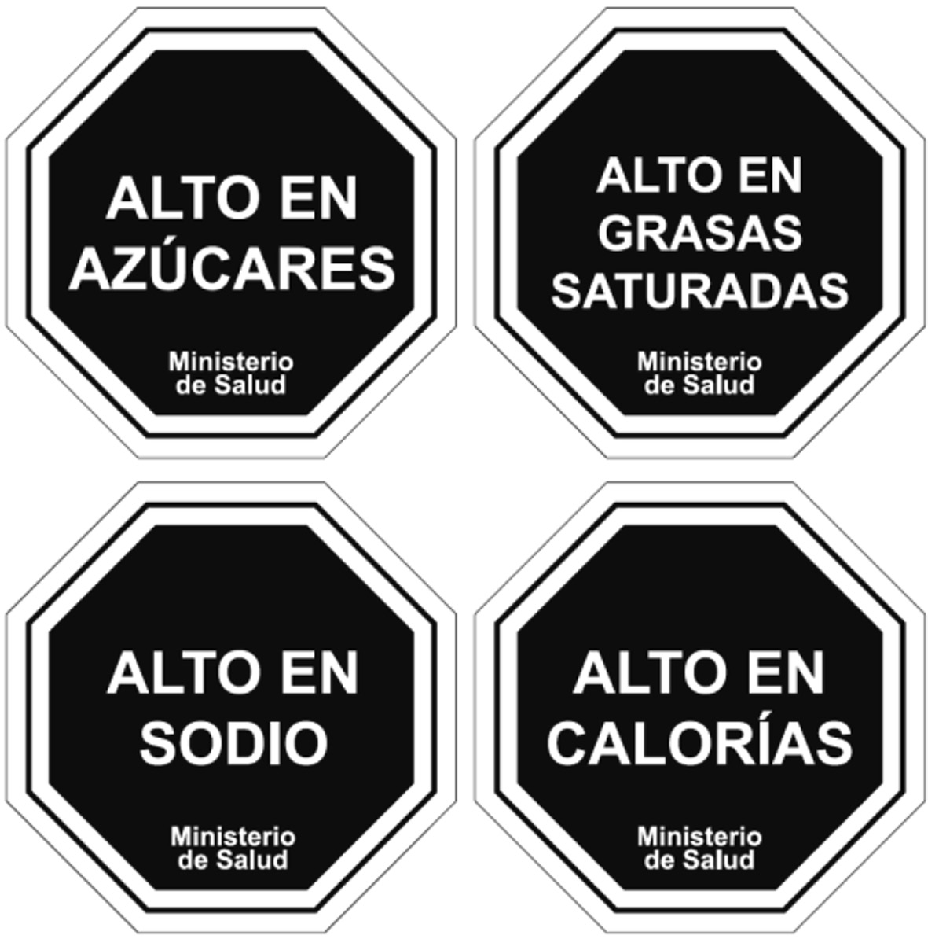

The graphic characteristics of the nutritional descriptors indicated in Diagram N°1 shall be the following:

a) Descriptor's Elements:

- Octagonal base containing the message.
2. Descriptor’s main message.
3. Signature of the Ministry of Health
4. Double white border separated by a black line

Example of elements in the "HIGH IN SUGAR" descriptor
b) "HIGH IN SUGAR" descriptor's proportions
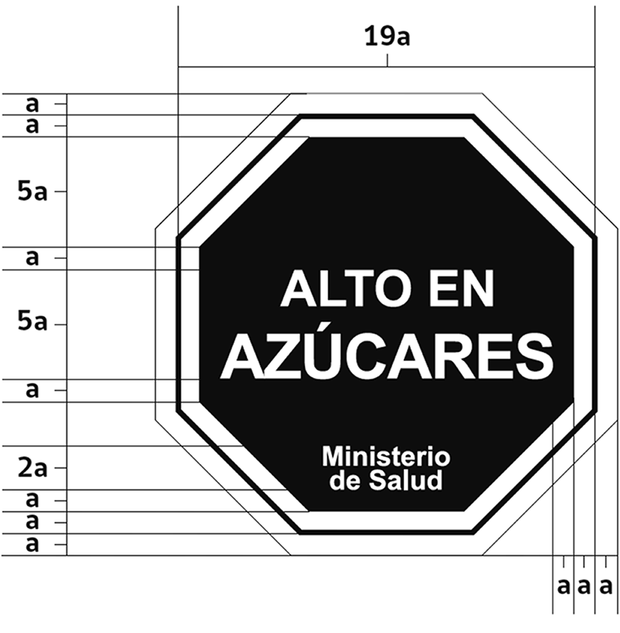


c) "HIGH IN SATURATED FATS" descriptor's proportions
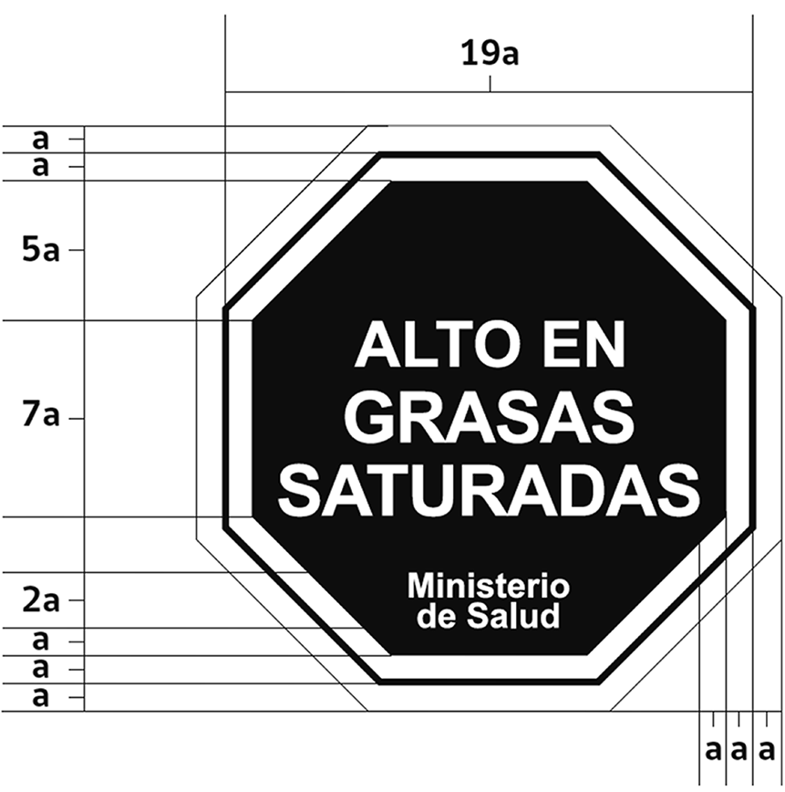

d) "HIGH IN SODIUM" descriptor's proportions
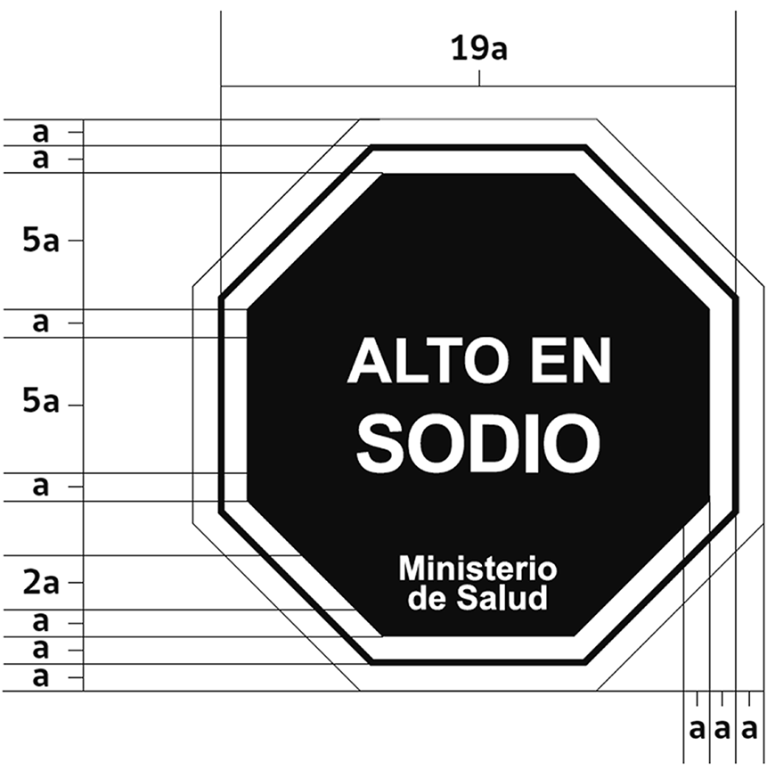

e) "HIGH IN CALORIES" descriptor's proportions
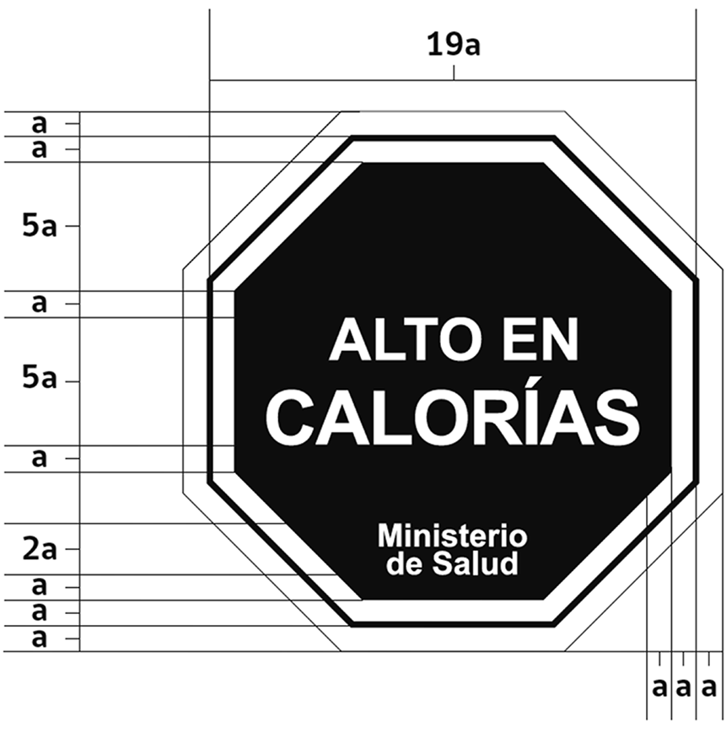

f) Color

The whole iconography of the symbol is composed of the color:

Color example:
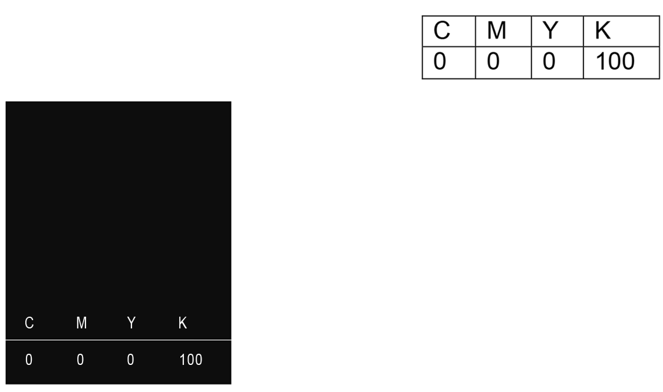

:g) Font
The font used in the iconography belongs to the "Arial" family, particularly in its "bold" format.

Font example:

h) Labeling of more than one descriptor:

Foods require more than one descriptor must do so pursuant to the following examples:

h.1) Labeling with 2 descriptors:


h.2) Labeling with 3 descriptors:
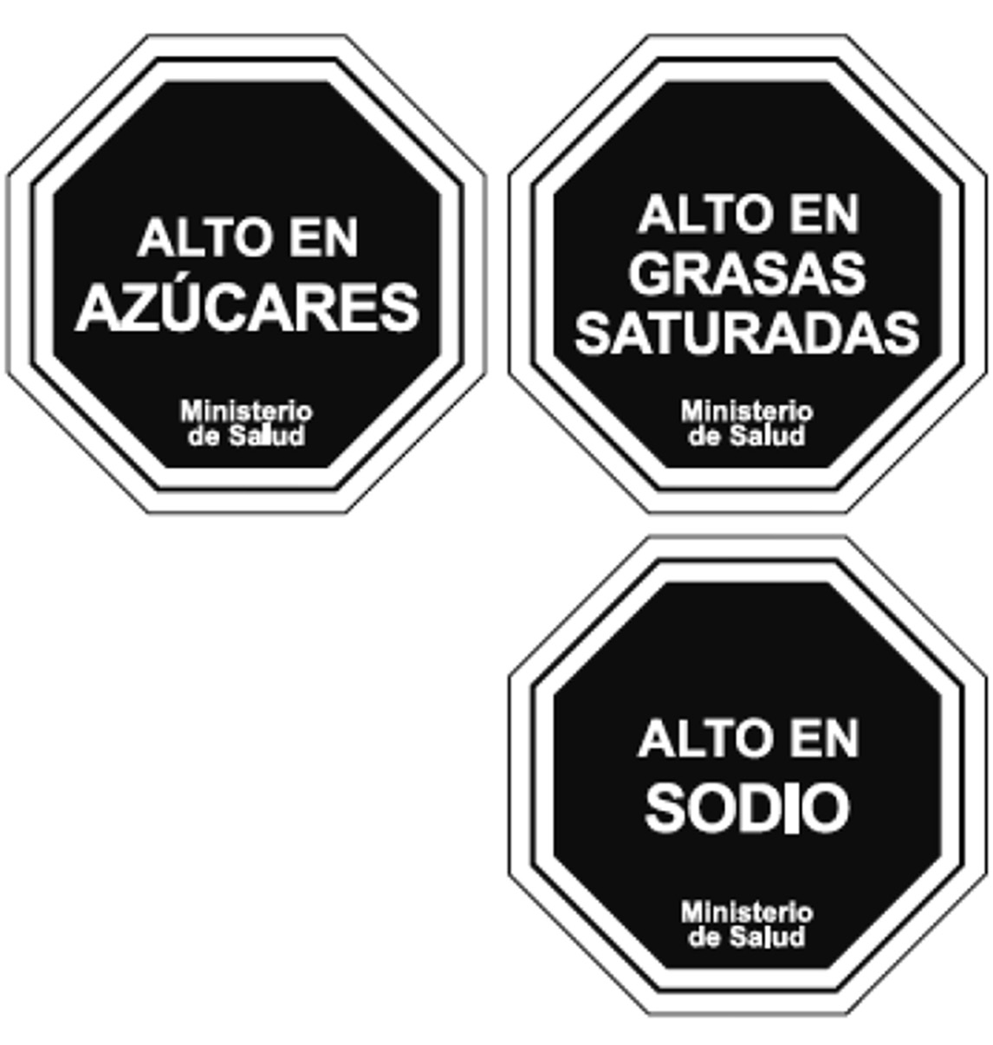
Format 1

Format 2:
This Format shall be used when the quadrant's height of the label's main front with the size belonging to the descriptor does not permit the use of Format 1.



h.3) Labeling with 4 descriptors:

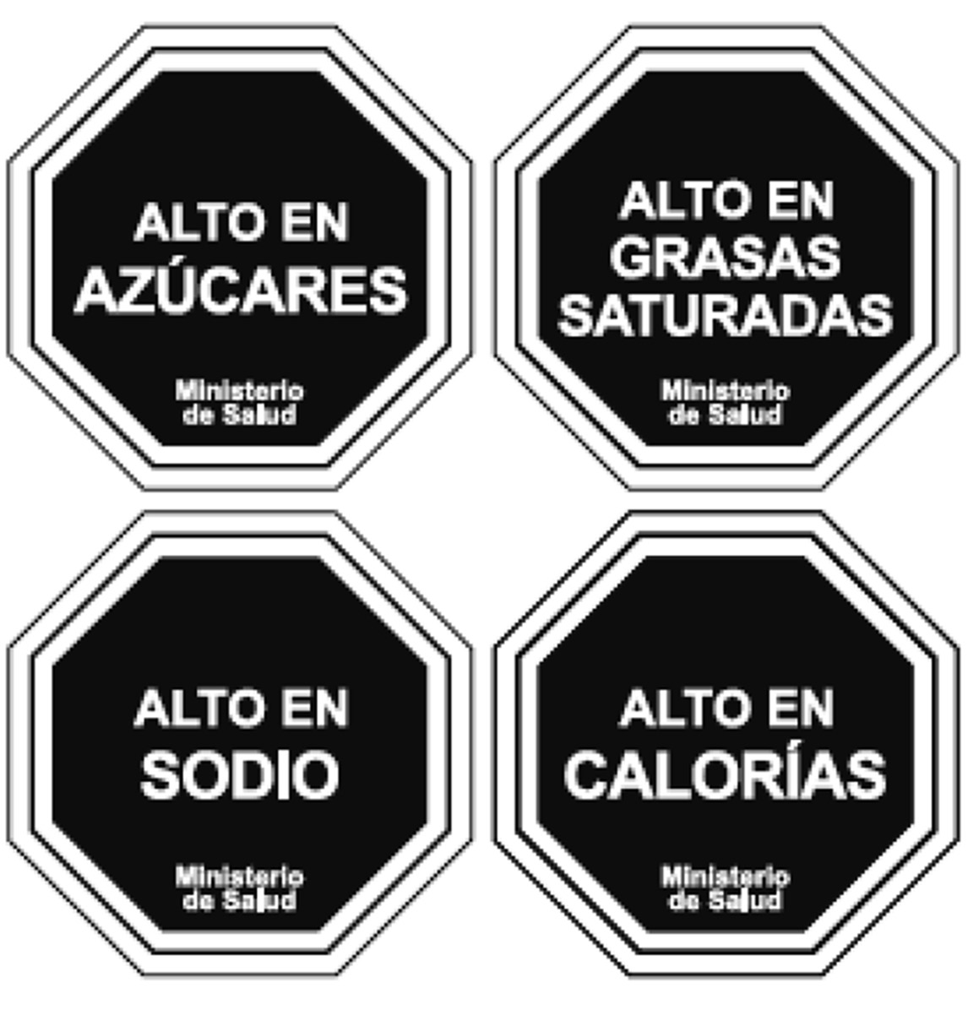
Format 1:

Format 2:
This Format shall be used when the quadrant's height of the label's main front with the size belonging to the descriptor does not permit the use of Format 1.

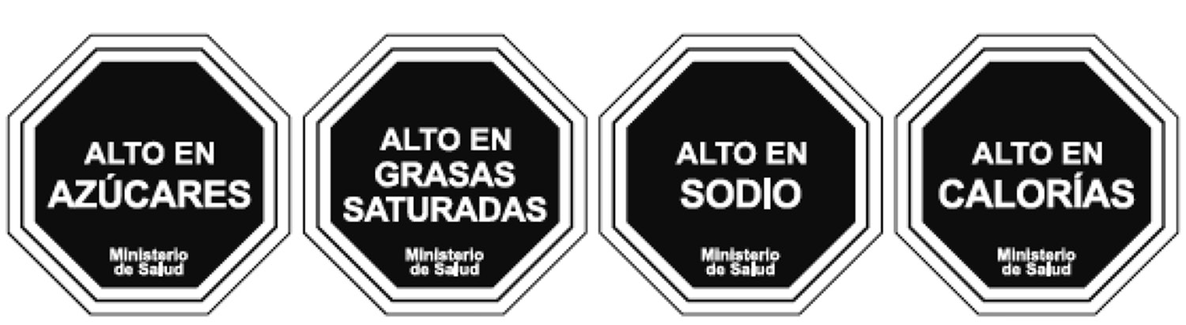

i) Distance between descriptors.

Descriptors shall be separated in such a fashion as to retain the same proportions described for the construction for each, as detailed below:

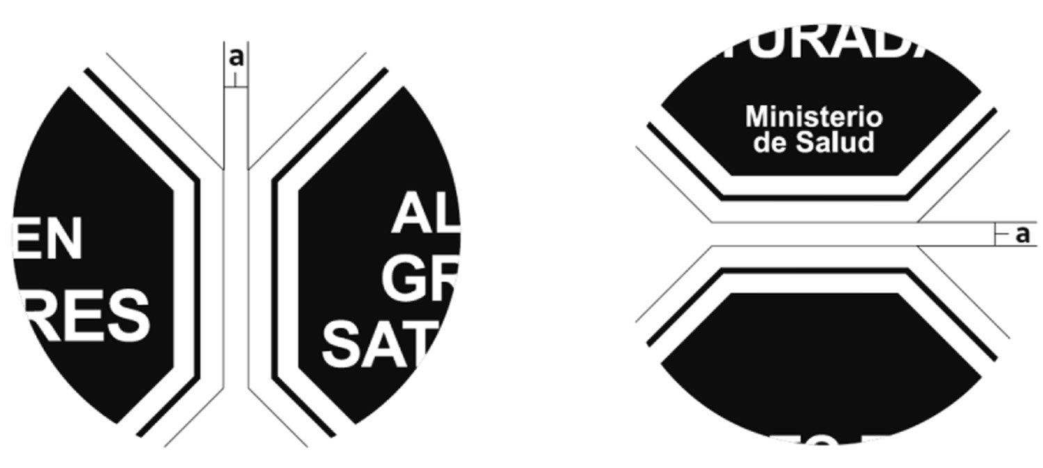

j) Minimum Size.

When labeling with the minimum size descriptor is applicable –1,5 cm high/1,5 cm wide–, "Ministry of Health" may be changed to "MINSAL."

Example:
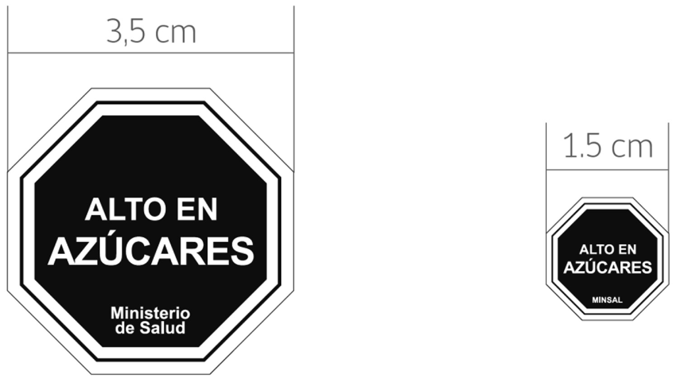

k) Position suggestion for the label's main front.
It is suggested that the position of the descriptor or descriptors to be labeled, as the case may be, should be at the higher right corner of the label's main front.

I) Examples of position for descriptors on different types of packaging

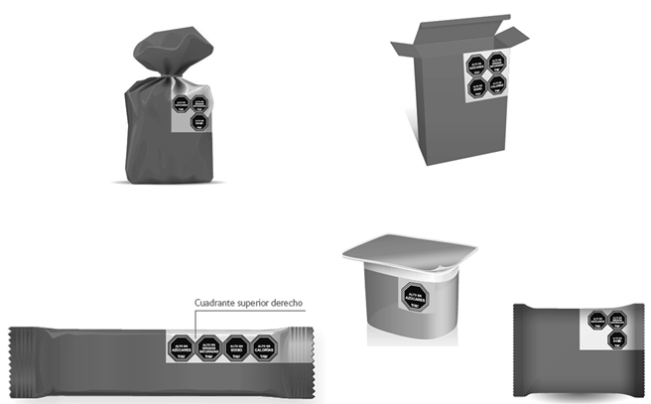

7) Replace Article 468 with the following:

"Article 468. Foods or ready-to-eat meals packaged for sale, retailed to be taken in portions and/or varieties predefined by the food manufacturer shall be labeled with the food's name, address of the factory where the food is manufactured, name of the manufacturer's legal representative, number and date of the health order authorizing the functioning of such food factory and name of the health authority who issued it, date of manufacture, expiration date or life of the product, instructions for its storage, net content and all the information described herein under Article 115, except for the number of portions per packaging.

This information shall be printed in the packaging or as part of a label adhered to the same in a visible, indelible way and be easy to read under normal purchase and use circumstances."

Table N° 2: Content limits of energy, sodium, total sugars and saturated fats in solid foods.
Nutrient or Energy | Date of entry into force | 24 months following entry into force | 36 months following entry into force
Energy kcal/100g | 350 | 300 | 275
Sodium mg/100g | 800 | 500 | 400
Total sugars g/100g | 22.5 | 15 | 10
Saturated fats g/100g | 6 | 5 | 4

Table N° 3: Content limits of energy, sodium, total sugars and saturated fats in liquid foods.

Nutrient or Energy | Date of entry into force | 24 months following entry into force | 36 months following entry into force
Energy kcal/100g | 100 | 80 | 70
Sodium mg/100g | 100 | 100 | 100
Total sugars g/100g | 6 | 5 | 5
Saturated fats g/100g | 3 | 3 | 3

ARTICLE 121.- In packages whose largest surface is less than 10 cm², the batch number, list of ingredients, and instructions for use may be omitted, with this information being placed in the larger package containing them.
Packaged foods whose largest surface (primary side) is less than 40 cm² are excepted from complying with the provisions of Article 115 herein. In this case the information should be placed in the larger package containing them.

Article amended, as shown in the text, by Decree 475/99, of the Ministry of Health, published in the Official Gazette on 01/13/00
Article amended, as shown in the text, by Decree 475/99, of the Ministry of Health, published in the Official Gazette on 01/13/00
Article replaced, as shown in the text, by Article 1, No. 6, of Decree No. 68/05, of the Ministry of Health, published in the Official Gazette on 01/23/06
Numeral replaced, as shown in the text, by Article 1, No. 1, of Decree 58/07, of the Ministry of Health, published in the Official Gazette on 06/16/07
Resolution No. 83/07, of the Ministry of Health, published in the Official Gazette on 07/07/07, approves the Technical Standard on Incorporation into the Registry of Biotechnological Events in Foods for Human Consumption
Numeral replaced, as shown in the text, by Article 1, No. 1, of Decree No. 58/07, of the Ministry of Health, published in the Official Gazette on 06/16/07
Article amended, as shown in the text, by Decree No. 57/05, of the Ministry of Health, published in the Official Gazette on 05/06/05
Numeral added, as shown in the text, by Decree No. 63/09, of the Ministry of Health, published in the Official Gazette on 12/11/09.
Numeral added, as shown in the text, by Article 1, No. 1 of Decree No. 88/10, of the Ministry of Health, published in the Official Gazette on 01/06/11
Numeral added, as shown in the text, by Article 1, No. 1 of Decree No. 88/10, of the Ministry of Health, published in the Official Gazette on 01/06/11
Subsection amended, as indicated in the text, by Decree No. 475/99, of the Ministry of Health, published in the Official Gazette of 01/13/00
Letter amended, as shown in the text, by Decree No. 115/03, of the Ministry of Health, published in the Official Gazette on 11/25/03 (Previous Amendment:
Letter amended, as shown in the text, by Article 1, No. 2, of Decree No. 88/10, of the Ministry of Health, published in the Official Gazette on 01/06/11
Letter replaced, as indicated in the text, by No. 2 of Article 1 of Decree No. 4/12, of the Ministry of Health, published in the Official Gazette on 01/09/13 (Previous Amendment: Decree No. 115/03, of the Ministry of Health, published in the Official Gazette on 11/25/03 (previous amendment: Decree 475/99)
Letter substituted, as indicated in the text, by Decree No. 115/03, of the Ministry of Health, published in the Official Gazette on 11/25/03
Subsection amended, as indicated in the text, by Decree No. 475/99, of the Ministry of Health, published in the Official Gazette of 01/13/00
Letter substituted, as indicated in the text, by Decree No. 475/99, of the Ministry of Health, published in the Official Gazette on 01/13/00.- The same decree establishes a period of six months to comply with that set forth in letter g). In the case of beverages sold in returnable plastic or glass containers, whose labeling is printed directly on the container, the period shall be two years. A period of six months is granted to market food products (labels printed prior to 05/13/97), which do not meet the labeling provisions contained in these Regulations.
Letter replaced, as indicated in the text, by Decree No. 807/97, of the Ministry of Health, published in the Official Gazette on 02/03/98
Letter amended, as indicated in the text, by Decree No. 115/03, of the Ministry of Health, published in the Official Gazette on 11/25/03
Exempt Resolution No. 427/10, of the Ministry of Health, published in the Official Gazette on 07/03/10, defines the list of food allergens that must be labeled
Paragraph added, as shown in the text, by Article 1, No. 2, of Decree No. 88/10, of the Ministry of Health, published in the Official Gazette on 01/06/11
Paragraph added, as shown in the text, by Article 1, No. 2, of Decree No. 88/10, of the Ministry of Health, published in the Official Gazette on 01/06/11
Letter amended, as shown in the text, by Decree No. 57/05, of the Ministry of Health, published in the Official Gazette on 05/06/05
Letter substituted, as shown in the text, by the Decree No. 57/05, of the Ministry of Health, published in the Official Gazette on 05/06/05
Letter replaced, as shown in the text, by Article 1, No. 3, of Decree 4/12, of the Ministry of Health, published in the Official Gazette on 01/09/13 (previous Amendment: Decree 807/97, of the Ministry of Health, published in the Official Gazette on 02/03/98)
Letter added, as indicated in the text, by Decree 115/03, of the Ministry of Health, published in the Official Gazette on 11/25/03
Article amended, as shown in the text, by Article 1, No. 3, of Decree No. 88/10, of the Ministry of Health, published in the Official Gazette on 01/06/11
Article amended, as indicated in the text, by Decree 115/03, of the Ministry of Health, published in the Official Gazette on 11/25/03
Subsection added, as shown in the text, by Article 1, No. 4, of Decree No. 88/10, of the Ministry of Health, published in the Official Gazette on 01/06/11
Article amended, as indicated in the text, by Decree 115/03, of the Ministry of Health, published in the Official Gazette on 11/25/03
Article amended, as indicated in the text, by Decree 57/05, of the Ministry of Health, published in the Official Gazette on 05/06/05
Article amended, as shown in the text, by Article 1, No. 5, of Decree No. 88/10, of the Ministry of Health, published in the Official Gazette on 01/06/11
Article substituted, as indicated in the text, by Decree 57/05, of the Ministry of Health, published in the Official Gazette on 05/06/05
Article replaced, as shown in the text, by Article 1, No. 2, of Decree 58/07, of the Ministry of Health, published in the Official Gazette on 06/16/07
Exempt Resolution No. 764/09, of the Ministry of Health, published in the Official Gazette on 10/05/09, approves the "Technical Standards on Nutritional Guidelines Indicated, for Statements of Health Properties of Foods." (Previous standard: Exempt Resolution 556/05)
Letter replaced, as shown in the text, by Article 1, No. 1, of Decree No. 14/11, of the Ministry of Health, published in the Official Gazette on 10/18/11
Article replaced, as indicated in the text, by Article 1, No. 3, of Decree 58/07, of the Ministry of Health, published in the Official Gazette on 06/16/07.-Effective as of 12 and 24 months after its publication in the Official Gazette, pursuant to its Article 2
Article amended, as shown in the text, by Article 1, No. 6, of Decree No. 88/10, of the Ministry of Health, published in the Official Gazette on 01/06/11
Letter added, as shown in the text, by Article 1, No. 2 of Decree No. 14/11, of the Ministry of Health, published in the Official Gazette on 10/18/11
Article replaced, as shown in the text, by Article 1, No. 3, of Decree No. 14/11, of the Ministry of Health, published in the Official Gazette on 10/18/11 (previous amendment: Decree 57/05)
Article amended, as shown in the text, by Decree No. 238/00, of the Ministry of Health, published in the Official Gazette on 05/26/00
Article substituted, as shown in the text, by Decree No. 475/99, of the Ministry of Health, published in the Official Gazette of 01/13/00
Article amended (repealing subsection), by Decree No. 238/00, of the Ministry of Health, published in the Official Gazette on 05/26/00
Article replaced, as shown in the text, by Article 1, No. 7, of Decree No. 88/10, of the Ministry of Health, published in the Official Gazette on 01/06/11
Article amended, as shown in the text, by Article 1, No. 4, letter a) of Decree 58/07, of the Ministry of Health, published in the Official Gazette on 06/16/07
Subsection added, as shown in the text, by Article 1, No. 4, letter b) of Decree 58/07, of the Ministry of Health, published in the Official Gazette on 06/16/07

